Module 8 : Maps in Tableau

1. Create a Symbol Map showing the Sales of Super store. Display the Population Data of US as the Data Layer.

Sample Screen shot of Output:

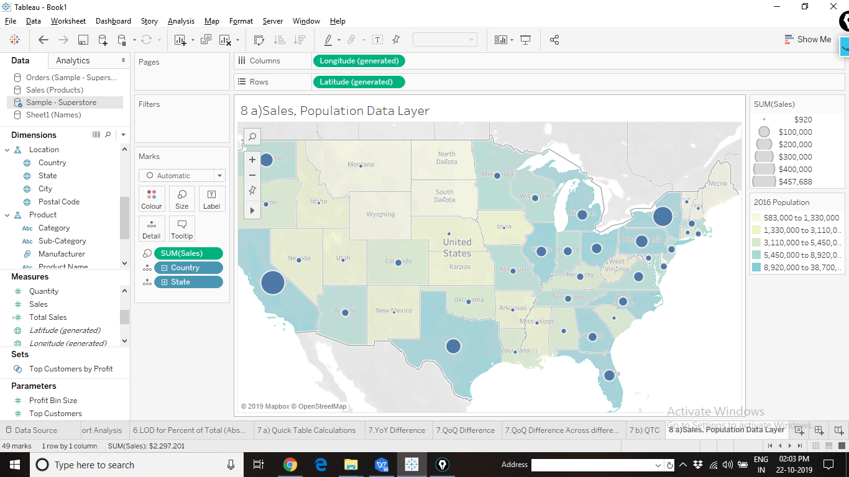

1. Divide United States into 3 different territories using the selection tools and Visual Grouping concept. Display the profit of each territory as a Label. *Hint: Group using (Country,State)*

Sample Screen shot of Output:

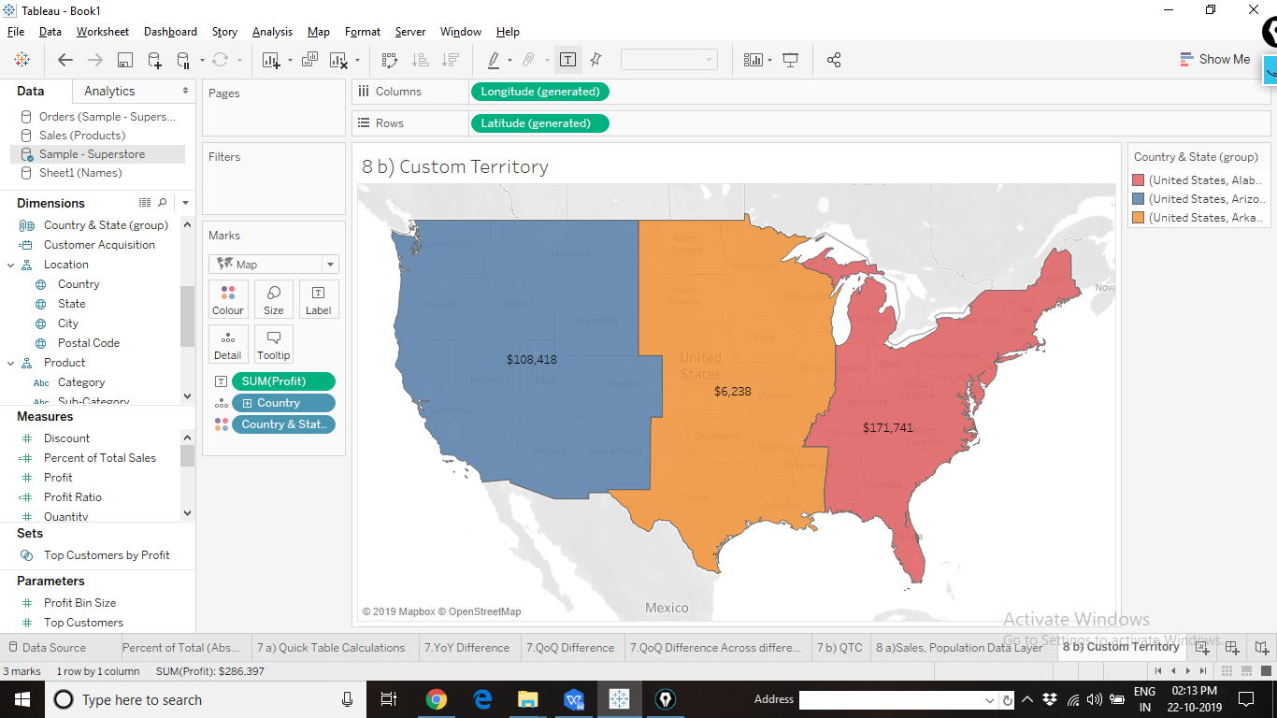

1. Create a Map of United States showing different states on the WMS map. Link to the WMS Map: [http://ows.terrestris.de/osm/service](http://ows.terrestris.de/osm/service" \t "https://community.tableau.com/thread/_blank)

Sample Screen shot of Output:

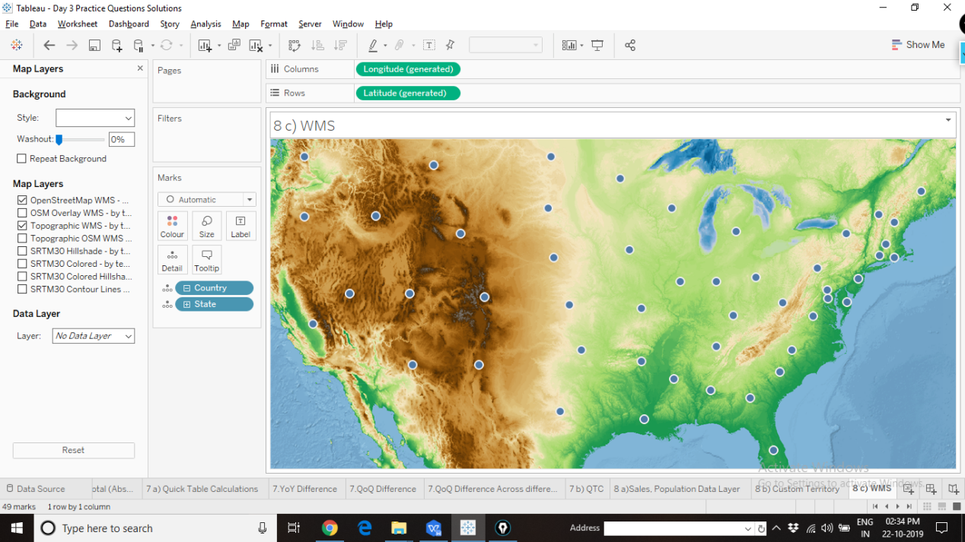

1. Use the “hong_kong_mtr.png” image and generate coordinates for all the stations on the “Island Line” and “Kwun Tong Line”. Hongkong MTR.xlsx data source is provided.

Sample Screen shot of Output:

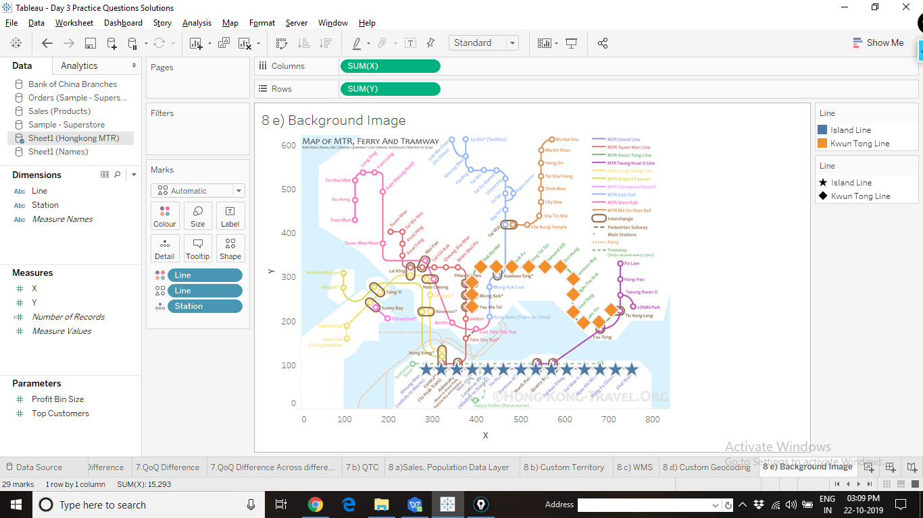

Coordinates used:

|  |  |  |  |  |
| --- | --- | --- | --- | --- |
| Line | Station | X | Y |  |
| Island Line | Sheung Wan | 285 | 90 |  |
| Island Line | Central | 320 | 90 |  |
| Island Line | Admiralty | 355 | 90 |  |
| Island Line | Wan Chai | 390 | 90 |  |
| Island Line | Causeway Bay | 425 | 90 |  |
| Island Line | Tin Hau | 460 | 90 |  |
| Island Line | Fortress Hill | 500 | 90 |  |
| Island Line | North Point | 535 | 90 |  |
| Island Line | Quarry Bay | 570 | 90 |  |
| Island Line | Tai Koo Shing | 605 | 90 |  |
| Island Line | Sai Wan Ho | 645 | 90 |  |
| Island Line | Shau Kei Wan | 680 | 90 |  |
| Island Line | Heng Fa Chuen | 715 | 90 |  |
| Island Line | Chai Wan | 753 | 90 |  |
| Kwun Tong Line | Yau Ma Tei | 390 | 233 |  |
| Kwun Tong Line | Mong Kok | 390 | 260 |  |
| Kwun Tong Line | Prince Edward | 390 | 287 |  |
| Kwun Tong Line | Shek Kip Mei | 410 | 323 |  |
| Kwun Tong Line | Kowloon Tong | 445 | 323 |  |
| Kwun Tong Line | Lok Fu | 480 | 323 |  |
| Kwun Tong Line | Wong Tai Sin | 518 | 323 |  |
| Kwun Tong Line | Diamond Hill | 555 | 323 |  |
| Kwun Tong Line | Choi Hung | 590 | 323 |  |
| Kwun Tong Line | Kowloon Bay | 620 | 295 |  |
| Kwun Tong Line | Ngau Tau Kok | 620 | 260 |  |
| Kwun Tong Line | Kwun Tong | 620 | 220 |  |
| Kwun Tong Line | Lam Tin | 643 | 195 |  |
| Kwun Tong Line | Yau Tong | 678 | 197 |  |
| Kwun Tong Line | Tui Keng Leng | 706 | 225 |  |